Classification models for demographic studies on contraceptive use: from the logistic model to XGBoost

1. Introduction
1.1 Problem Statement
This paper aims to develop and implement a supervised statistical learning model to estimate contraceptive use among a demographic sample of Indian women. The problem is a binary classification, where the response variable describes contraceptive use based on a set of sociodemographic and geographic predictors (e.g. age, education level, area of ​​residence, region, and number of children).

1.2 Cross-Entropy
The evaluation of the predictive quality of implemented models is based on the Cross-Entropy metric, commonly known as Log-Loss. Unlike metrics such as Accuracy, Log-Loss quantitatively assesses the calibration of estimated probabilities, severely penalizing models that exhibit overconfidence in the face of an incorrect prediction. Mathematically, this function for a dataset of N observations is defined as follows:
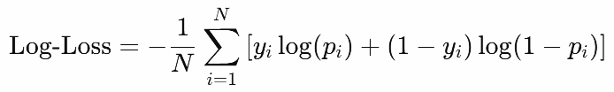
where $y_{i}∈\{0,1\}$ represents the real class and $p_{i}∈[0,1]$ indicates the probability estimated by the model for the success class.

2. Exploratory Data Analysis and Preprocessing
2.1 Dataset Structure and Data Cleaning
The training dataset consists of 18,314 observations and 8 variables. The first phase of the analysis verified the presence or absence of missing values ​​(NA) in the dataset. The result was the absence of NA in both the training and test sets.
The identifying variable ID was removed from both datasets because it lacked predictive power and could potentially cause problems in the analysis.

2.2 Variable Transformation and Coding
The textual variables (character) were converted into factors (Factor). To ensure more accurate interpretation by the implemented algorithms, the variables education (levels: None, Low, Intermediate, High) and child (levels: 0, 1, More than 1) were transformed into ordered factors. Conversely, the variables state, religion, and area were treated as unordered nominal factors.

2.3 Distribution Analysis
The descriptive analysis of the variables highlights two important aspects that justify some of the choices that will be made:
- Target Imbalance and Clipping: The contraceptive variable shows a moderate imbalance: the use class (1) represents 73.4% of the sample, while non-use (0) represents 26.6%. This disproportion leads the models to estimate generally high probabilities, with the risk of generating leaves with exact probabilities of 0 or 1 in tree-based methods. This justifies the use of probabilistic clipping at ${10}^{-5}$ to avoid infinite penalties on the test set.

- High Number of Levels and XGBoost: The state variable has 33 levels with highly fragmented distributions. Hence the choice to use XGBoost with One-Hot Encoding, ideal for efficiently handling matrices full of zeros.

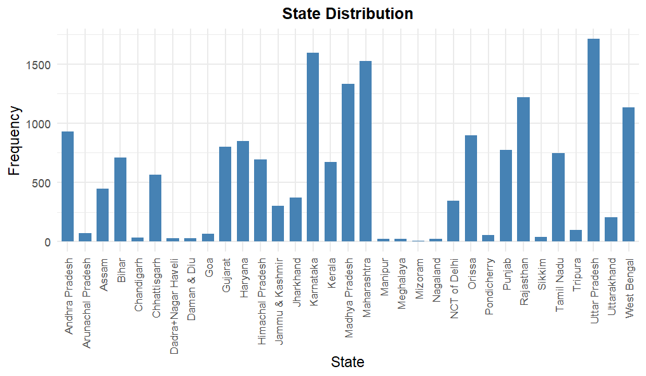
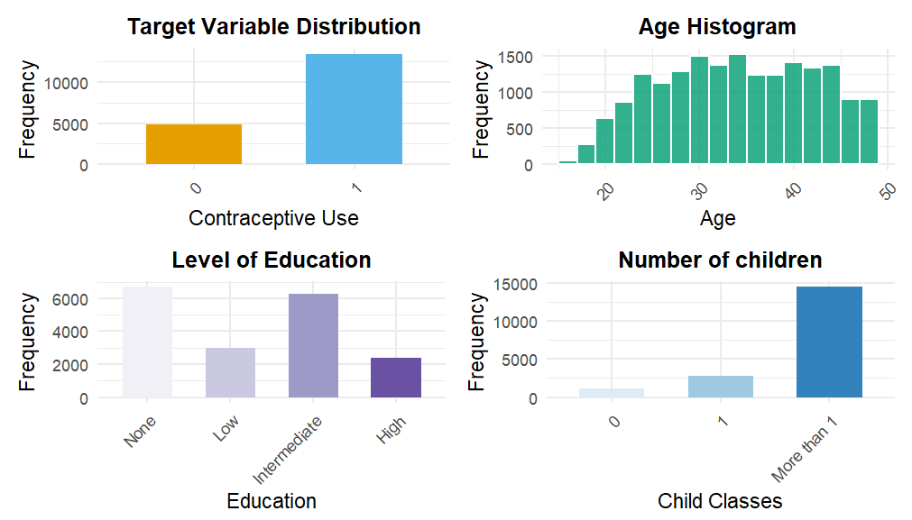

3. Validation and Loss Function
3.1 Hold-out Validation
To ensure a rigorous and unbiased estimate of the generalization error (Expected Prediction Error), a hold-out validation was implemented. The original training dataset was randomly partitioned into a training subset (train_set, 80%, equal to 14,651 observations) and a validation subset (val_set, 20%, equal to 3,663 observations).
This validation technique is also convenient for the subsequent implementation of XGBoost, which uses a validation set for its Early Stopping regularization technique.

3.2 Implementation of Log-Loss and Clipping
To calculate the error on the validation set, a function was written that calculates the log-loss by incorporating a probability clipping technique. The reason for this choice is due to the presence of the logarithm in the log-loss. If the model assigns a woman an exact probability of zero or one and is incorrect, the calculation fails because the logarithm of zero does not exist and tends to minus infinity, thus ruining the results.
This choice protects against overconfidence in the model. By forcing the extreme probabilities to fall within a controlled range, such as by transforming zero into a very small but positive value, the model accepts that it will always lose some of its correct predictions, but it insures against the risk that a single large error in the test set will generate a huge penalty.

4. Implementation and Comparison of Predictive Models
4.1 Baseline Model: Logistic Regression (GLM)
A Binomial Logistic Regression was implemented as the initial model. The model assumes a linear relationship between the log odds of the event and the socio-demographic predictors. The model returned a Log-Loss on the validation set of 0.46125, demonstrating a good starting point compared to the "blind" model that assigns all observations a probability of 0.5. However, this approach analyzes women's characteristics in isolation, without the joint effects of multiple variables (such as how age affects outcomes differently depending on geographic area of ​​residence). To overcome this rigidity of the linear model, it was decided to transition to tree-based algorithms.

4.2 Intermediate Model: Random Forest
To overcome the limitations of the logistic model, a Random Forest model was trained using the efficient ranger package. This method combines two techniques: bootstrap aggregation (bagging) and random feature selection. Together, these techniques create many different trees, reduce mutual correlation, and lower the overall variance of the model. Geometrically, each decision tree divides the multidimensional space of variables into separate and distinct regions through simple binary splits (yes/no). For each new data point that falls within a specific region, the tree assigns as its prediction the mean probability (the mean class proportion) of the training data present in that same region.
In this project, the algorithm builds a set of 1,000 independent decision trees. The parameter mtry (the number of variables randomly selected at each split) was set to its default value of $floor(\sqrt{p})$, where p is the number of predictors. In this specific case, mtry = 2. Limiting the number of variables in each split is crucial because it prevents the trees from becoming too similar and from always using only the most dominant predictors. Furthermore, the probability = TRUE option forces the algorithm to calculate actual estimated probabilities rather than clear-cut classifications.
The model showed significant improvement, reducing the validation log-loss to 0.45708. This result confirms that tree-based non linear models perform better for this dataset than standard linear models.
4.3 Advanced Model: eXtreme Gradient Boosting (XGBoost)
The maximum performance increase was achieved using the XGBoost algorithm. Unlike Random Forest, which builds independent trees in parallel, boosting is a sequential technique where each new tree is trained specifically to correct the errors made by the previous trees. Compared to traditional boosting algorithms, XGBoost offers advanced regularization and overfitting control systems. The code leveraged the library's key features:
- Overfitting Management: To limit model complexity, the maximum depth (complexity) of the trees was reduced to max_depth = 4 (leaves) and a very slow learning rate was set (eta = 0.01). This allowed to control the leaves of the tree so as not to have a very small number of observations in a leaf and risk sure predictions (0 or 1).

- Early Stopping: Using the early_stopping_rounds = 100 function, the training process was automatically stopped as soon as the Log-Loss on the validation set stopped improving.

- Optimization Function: By setting the binary:logistic objective, the algorithm directly optimized the metric of interest, generating calibrated probabilities, then strengthened by the final clipping.

5. Final Results and Conclusions
The overall results show a trend of monotonic improvement as the model's computational complexity and the level of regularization applied increase:
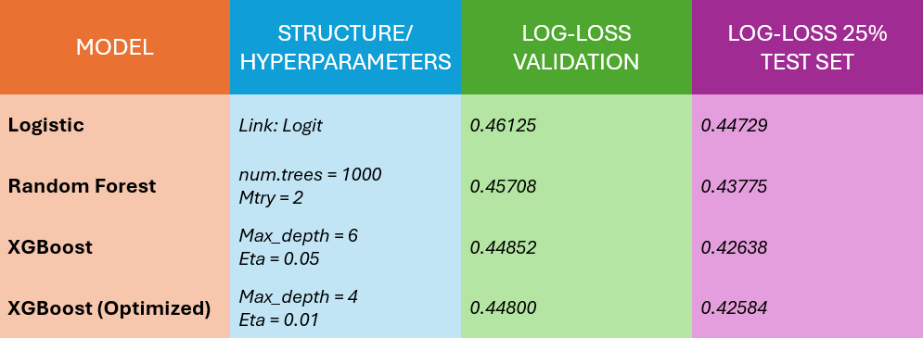
The table compares the Log-Loss estimated in local validation (Hold-out 80/20) with that calculated on 25% of the overall test set.
A consistent and clear improvement in the metric is observed when switching from the baseline linear model (Logistic, Log-Loss of 0.46125) to decision tree-based algorithms. The Random Forest (0.45708) and XGBoost demonstrate superior ability to capture the complex interactions between the dataset's socio-demographic and geographic variables.
The best overall model is the optimized XGBoost (Max_depth = 4, Eta = 0.01), which recorded the lowest score both in validation (0.44800) and on the 25% of the test set (0.42584).
This success highlights the crucial importance of regularization: by reducing the depth of the trees and slowing the learning rate, the model avoided overfitting, significantly improving its overall accuracy.

